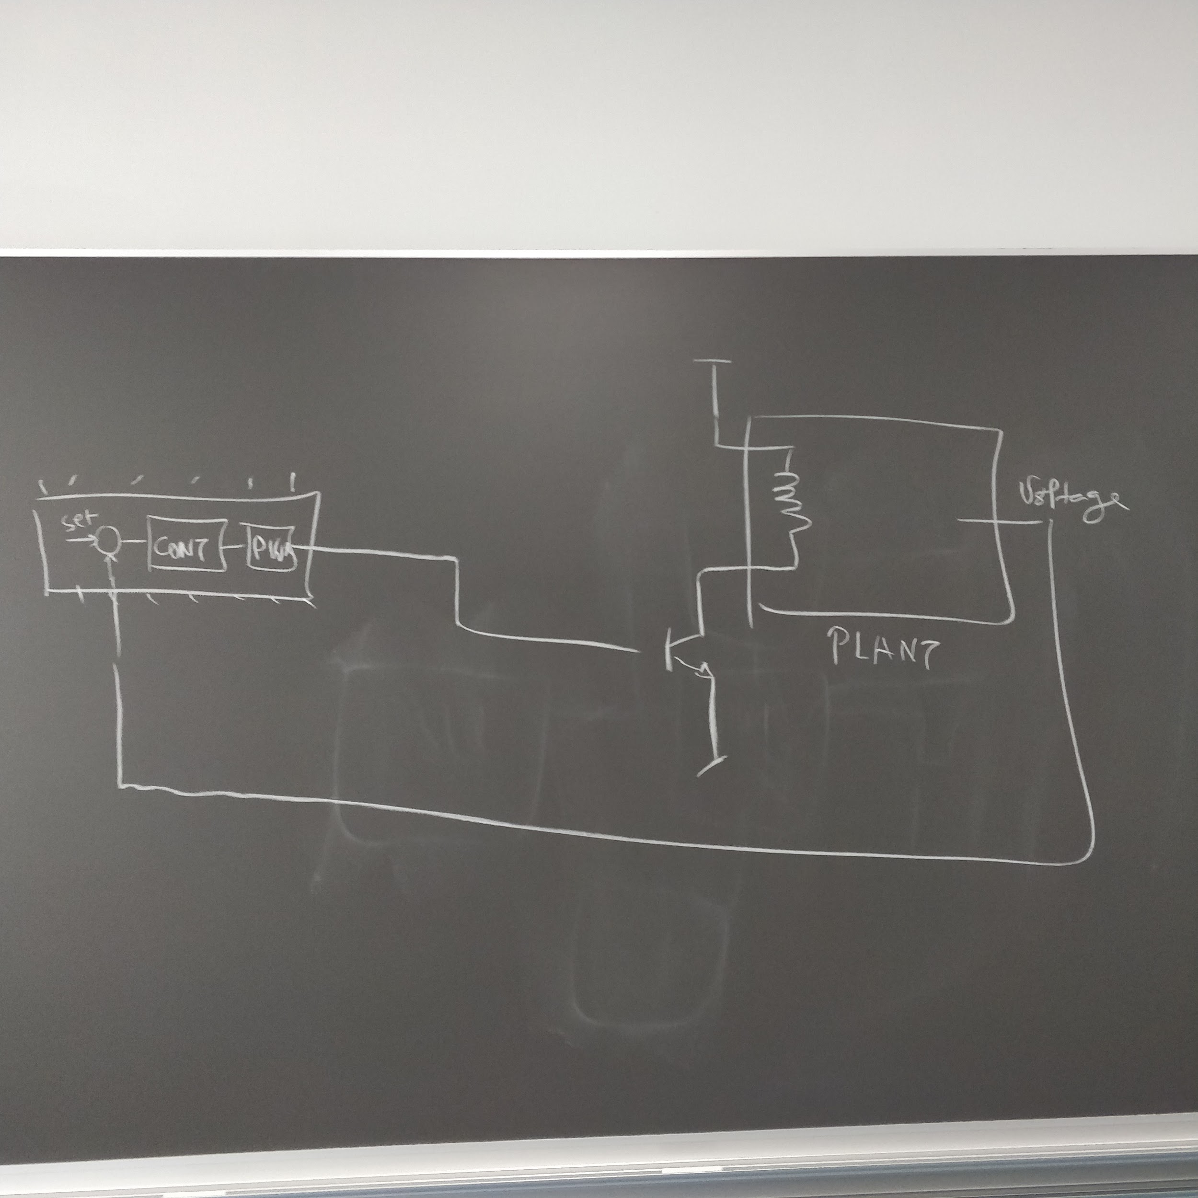

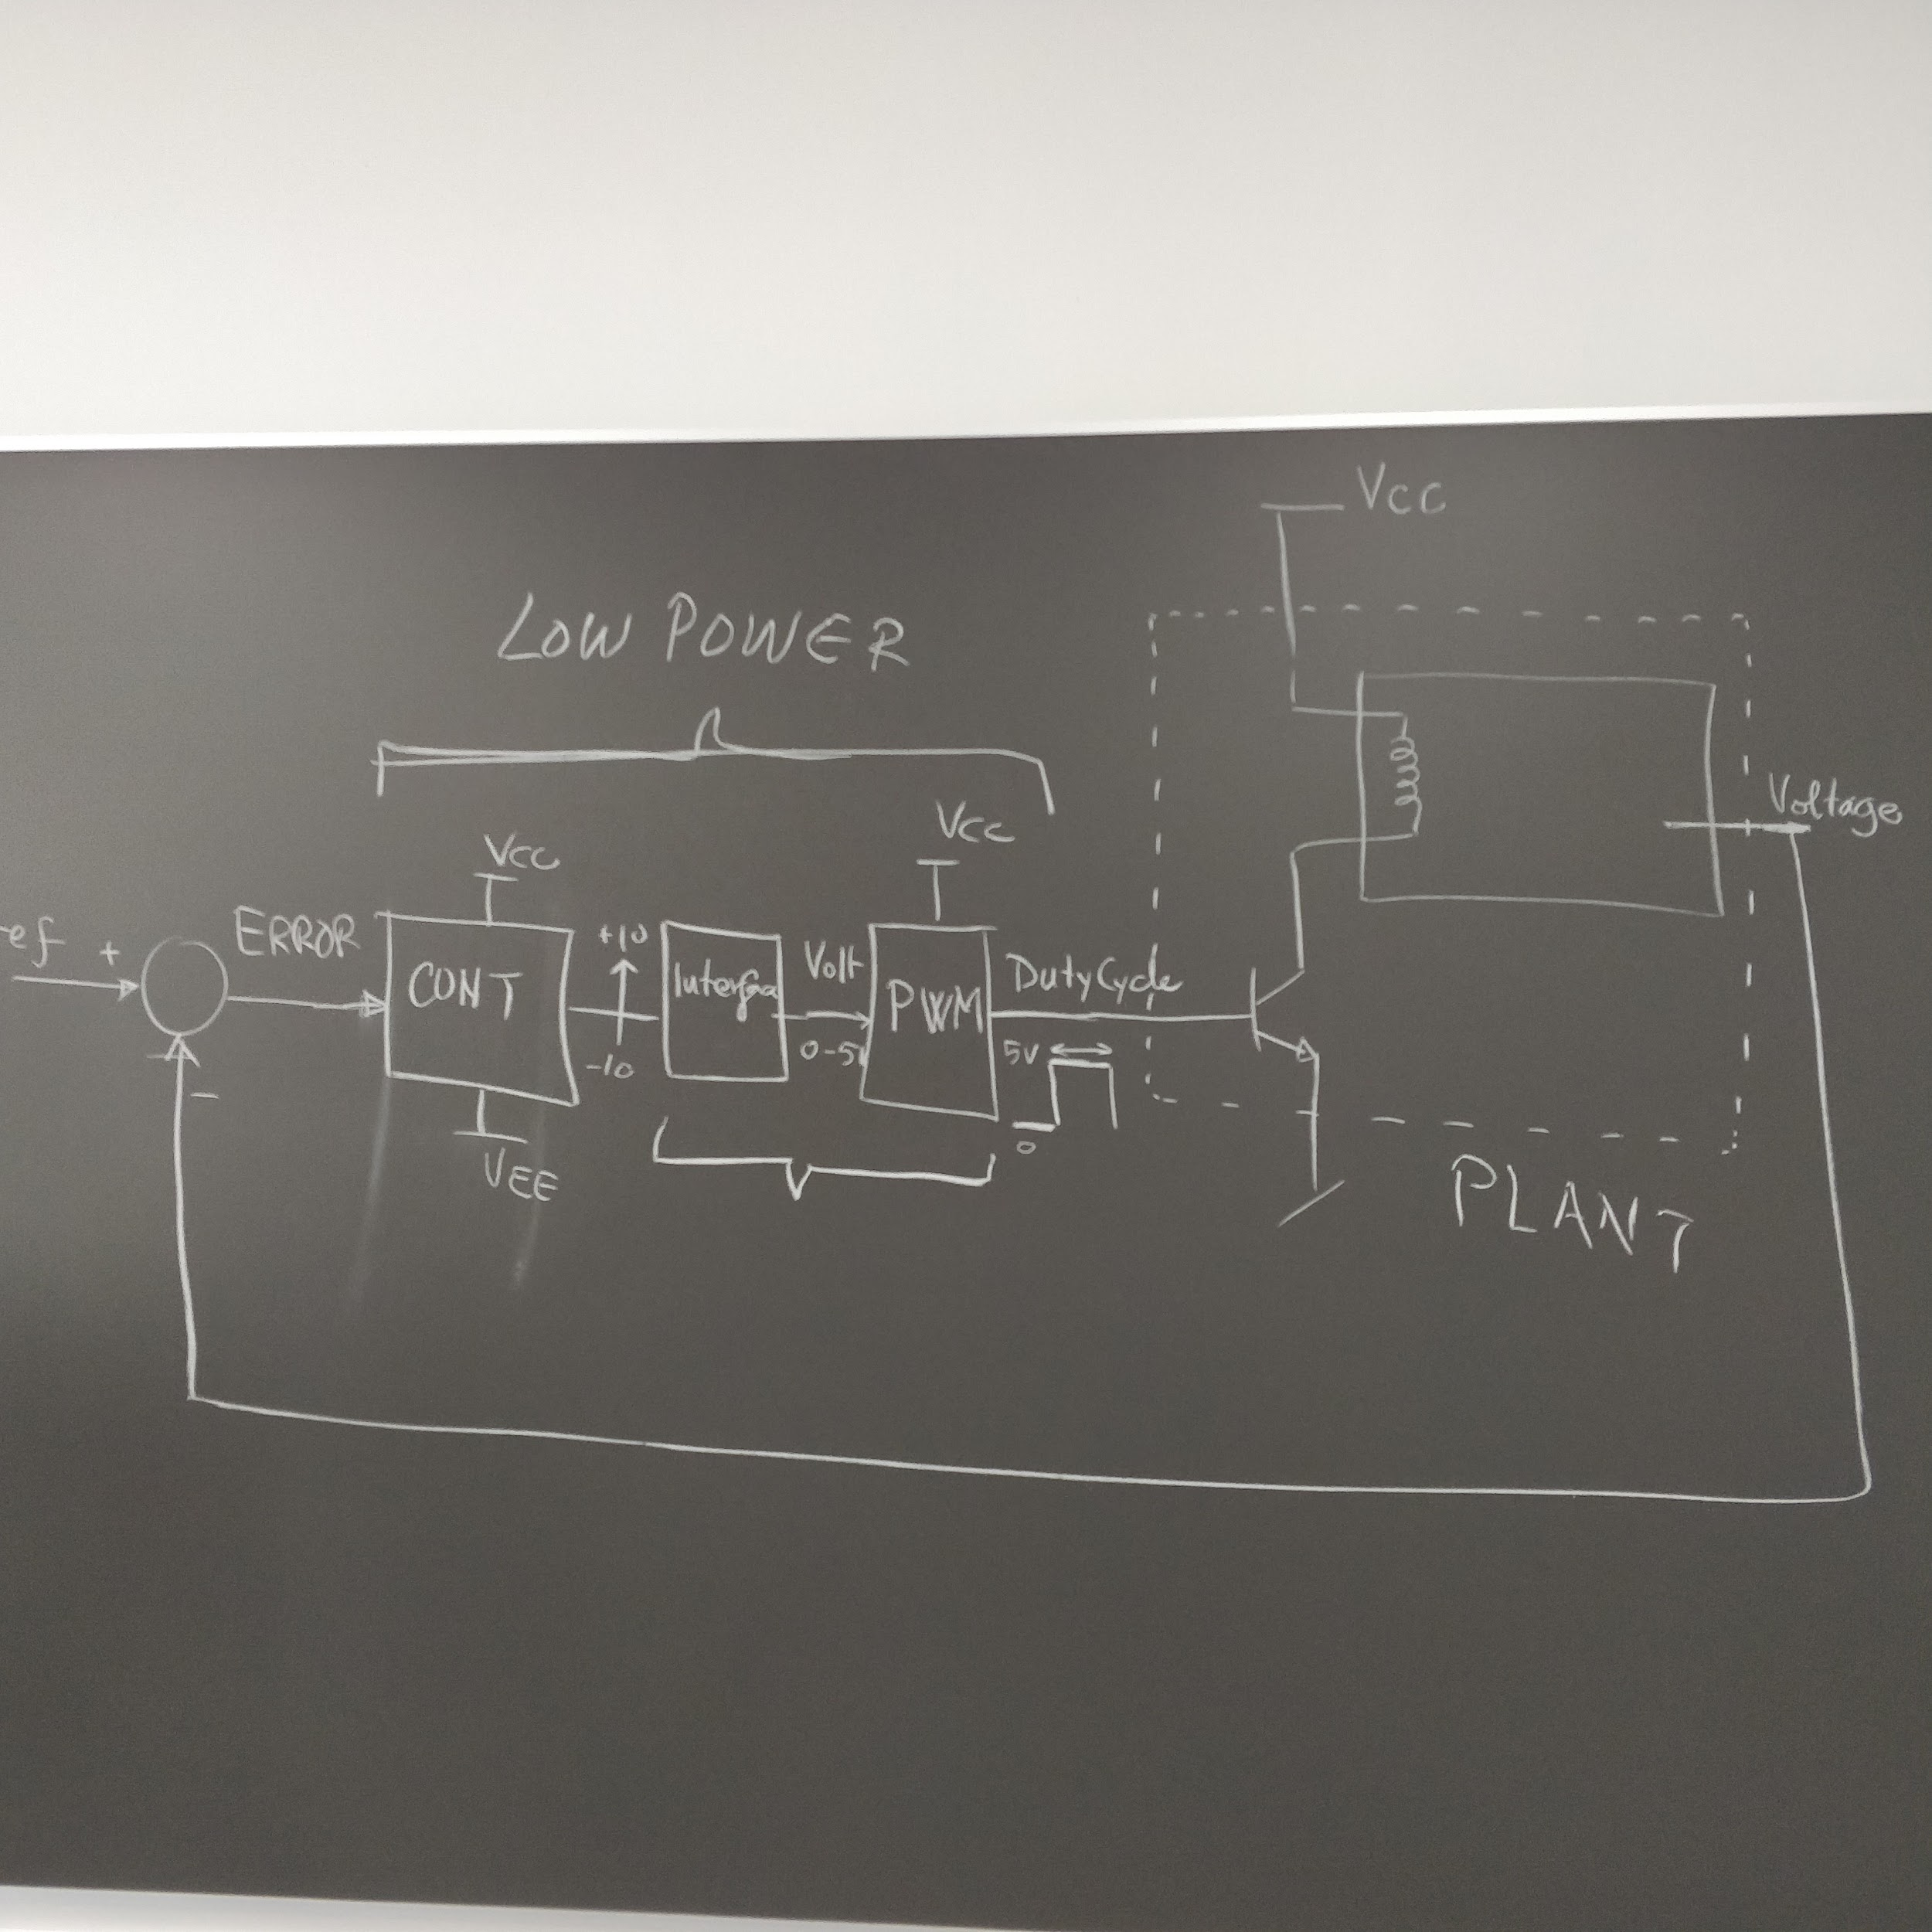

Links:

<https://www.onsemi.com/pub/Collateral/SG3525A-D.PDF>

<https://dk.rs-online.com/web/p/pwm-spaendings-mode-kontrollere/6200521/>

<http://www.components-shop.com/datasheets/9f/KA7500C.pdf>

<https://electronics.stackexchange.com/questions/115535/how-to-rescale-10-10v-to-0-5-v>

<https://electronics.stackexchange.com/questions/115502/convert-from-a-specifc-range-to-another-one>

Denne PWM spændingsdriftkontroller har vi bestilt:

<https://dk.rs-online.com/web/p/pwm-spaendings-mode-kontrollere/6200543/>

<https://datasheet.octopart.com/UC3525AN.-Texas-Instruments-datasheet-8198083.pdf>

<http://www.ti.com/lit/ds/symlink/uc3525a.pdf>